1. Create JOB and Location table structures.

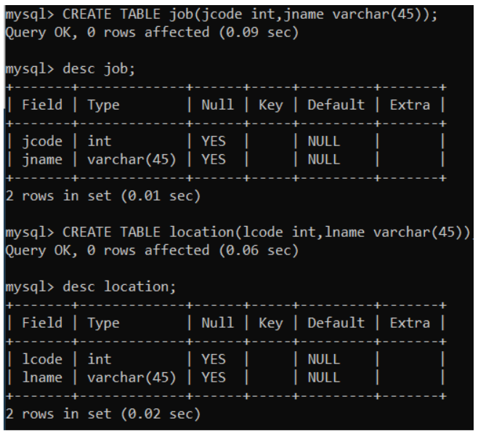

**2. Return all the products Name, Unit price, New Price (Unit price *1.5).**

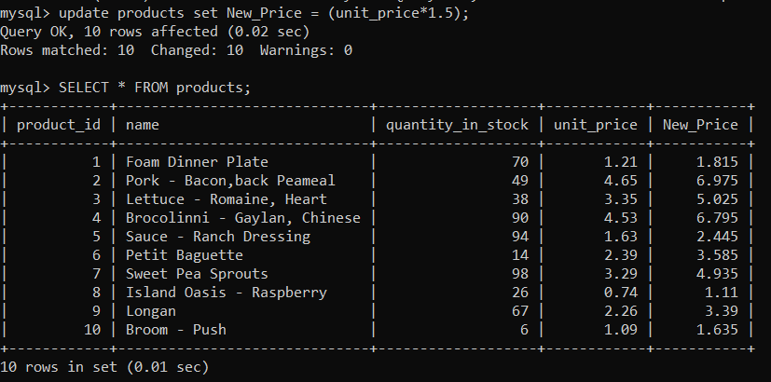

**3. Get the orders placed this year.**

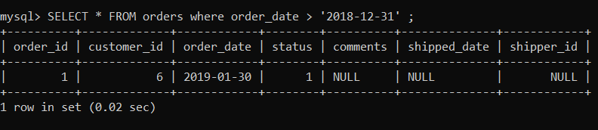

**4. From the order items table get the item order #6, where the total price is greater than 30.**

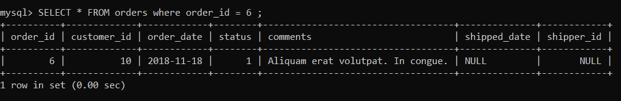

**5. Return products with quantity in stock equal to 49,38,72.**

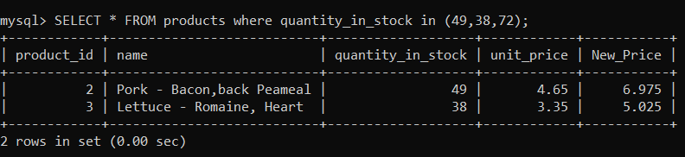

**6. Return customers born between 01/01/1990 and 01/01/2000**

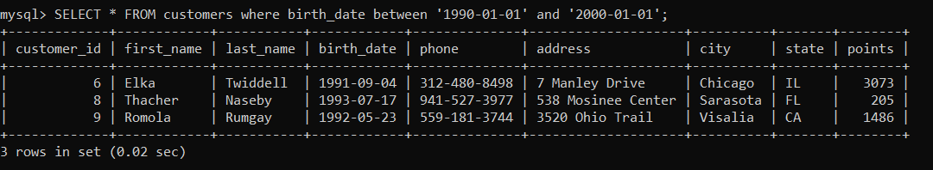

# 7. Get the customers whose address contain ‘Vijayawada’ or ‘Hyderabad’.

Ans:

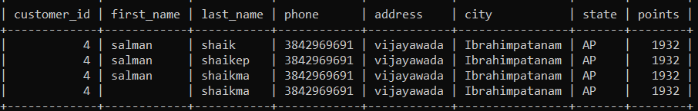

**8. Get the customers whose phone Number ending with 9.**

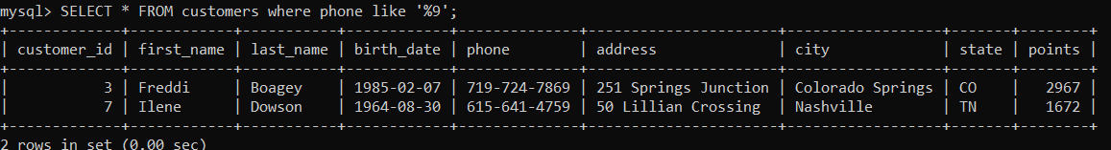

**9. Get the customers whose phone Number ending with 9.**



10. Get the customers whose last name End with EP or HI

**Ans:**



# **11.** Get the customers whose last names start with MA or contain NI.

Ans: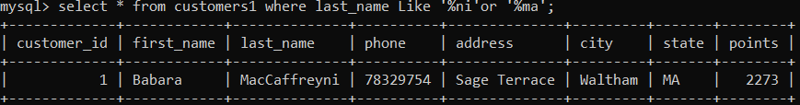

**12. Get the customers where last names contain R followed by I or M** 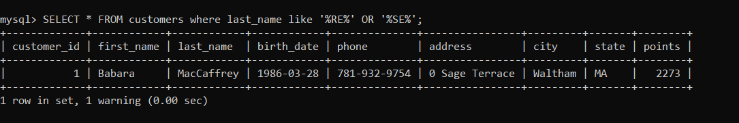

# 13. Get the customers whose first names are ‘Elka’ or ‘Ambur’.

**Ans:**



**14.** Get the customers whose last name End with EY or ON.

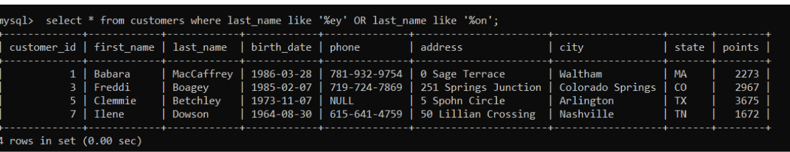

**15.** Get the customers whose last names start with MY or contain SE.

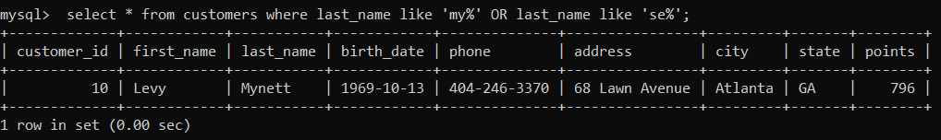

**16.** Get the customers where last names contain B followed by R or U

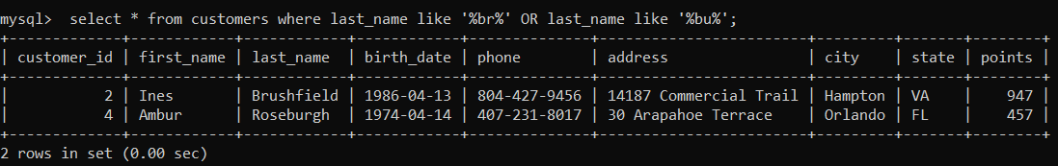

**17.** Get the orders that are not shipped

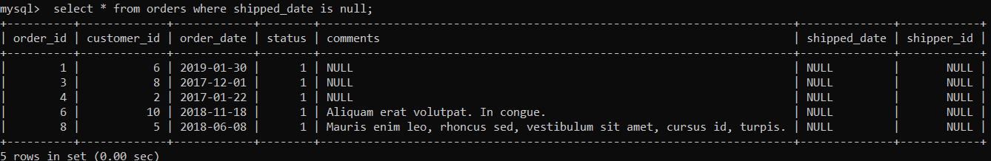

**18.** Get the orders where Id equals 2 orders and total price in descending order.

**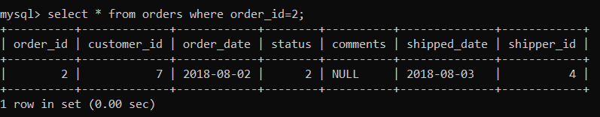  
19.** Get the top three loyal customers.

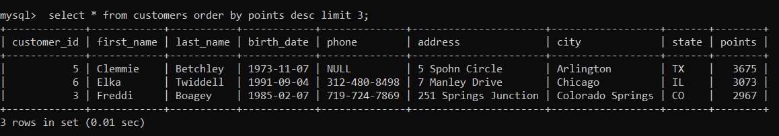

**20.** Get the orders and Name from product followed by product ID, quantity then unit Price.

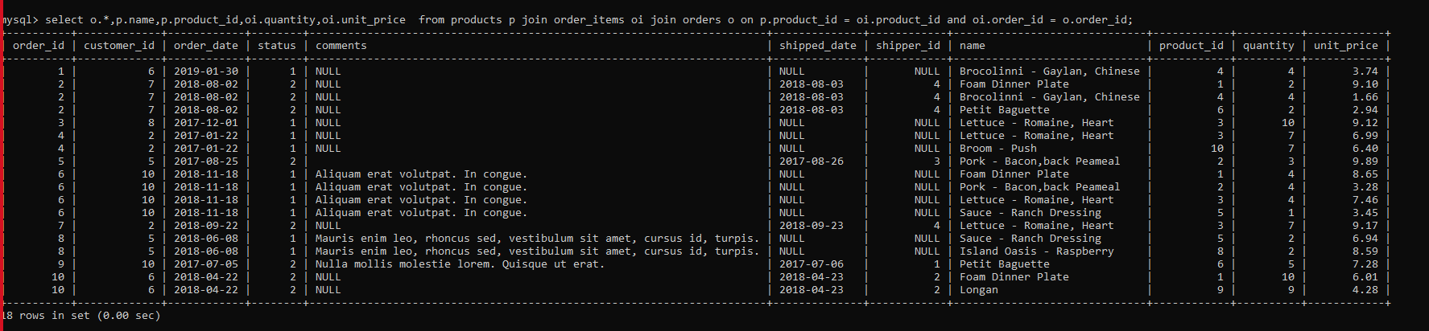

**21.** List all the managers whose name end with S;

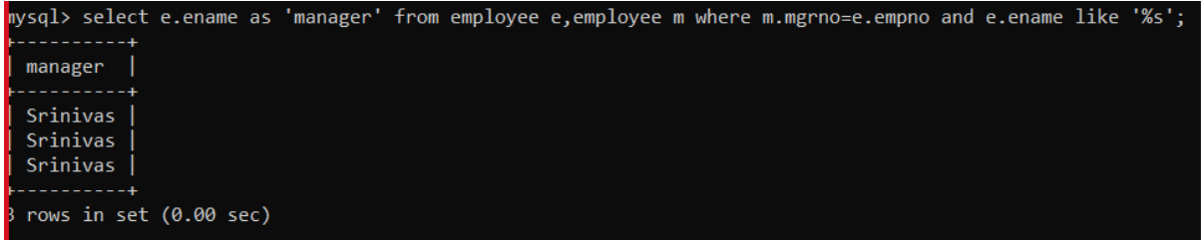

22. List the details of all employees who are either manager of analyst;

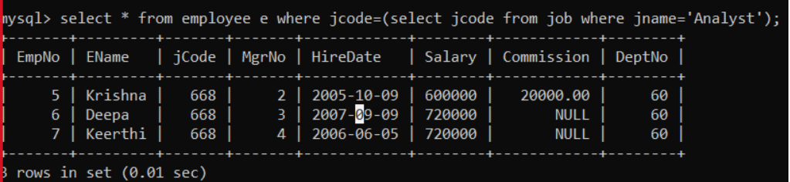

23. List the details of all employees who are working under 3 or 4 employee numbers;

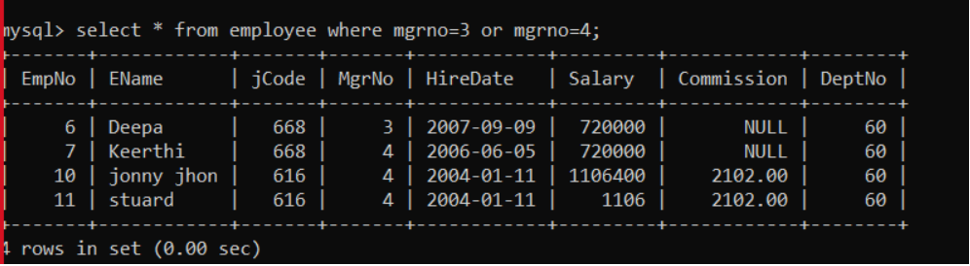

24. write a query to display total salary in department name wise.

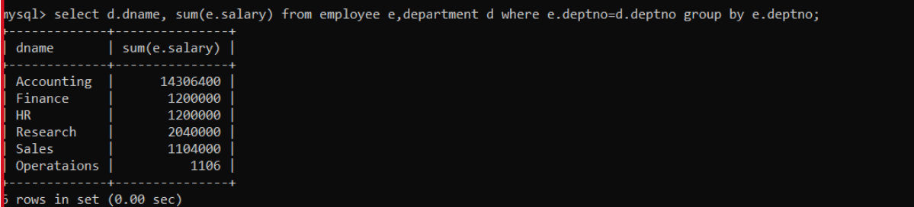

25. List the max Sal of employees working in department 40;

26. Display min and max salary of each department.

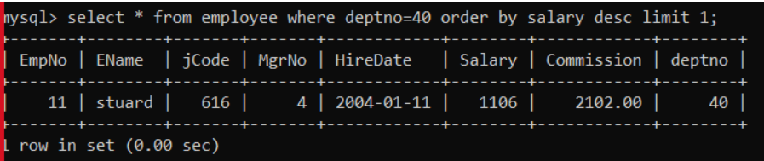

27. Find the no of employees in each job category.

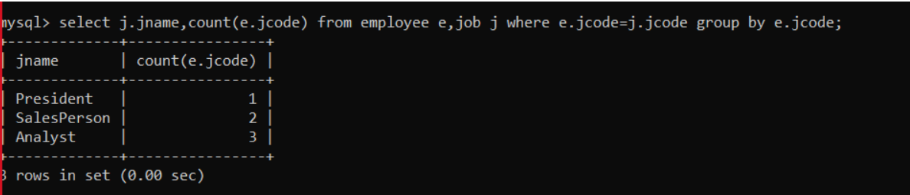

28. Display details of department only if their max salary exceeds 800000.

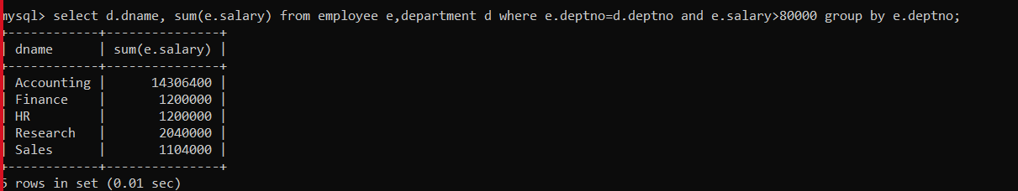

29. List the departments and the no of employees in each department.

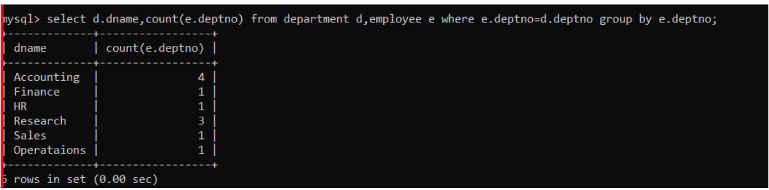

30. Display the details of department where at least 2 employees are present.

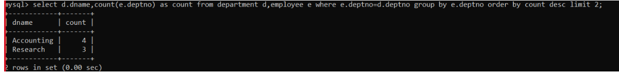

31.List all Employees in ascending order of their empno.

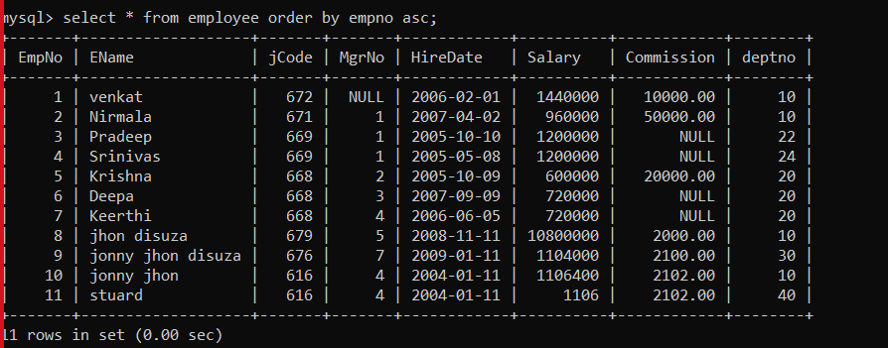

32.List max, Min, Avg salary of employee in ascending order of their avg salary.

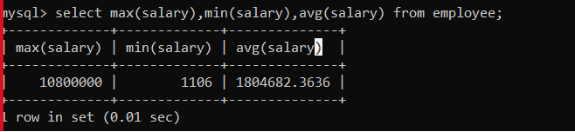

# 33. Combining order, status and customer’s tables get the output as below table.

Ans:

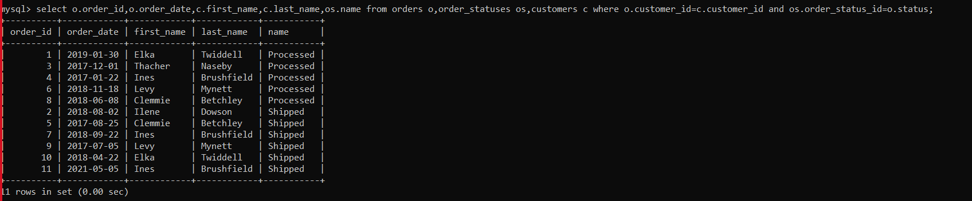

34. Get the output like below table by using Joins

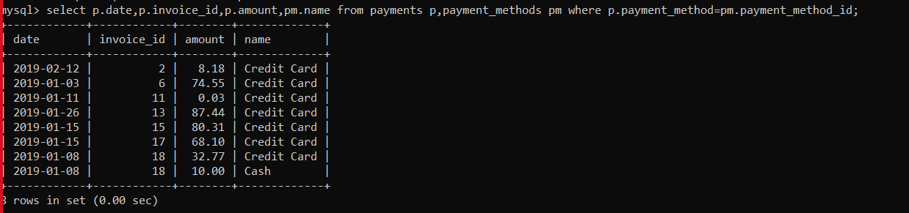

35. Get the output like below table by using JOIN

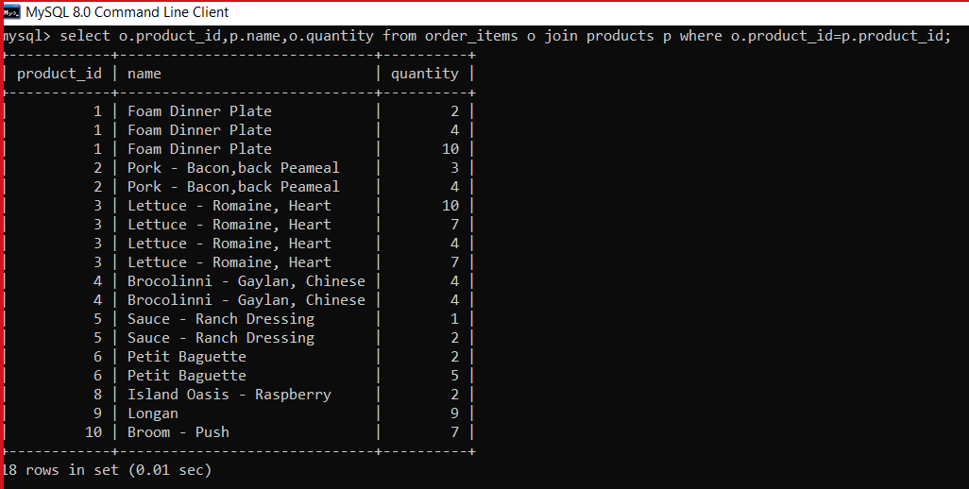

36. Get the output like below table by using JOIN

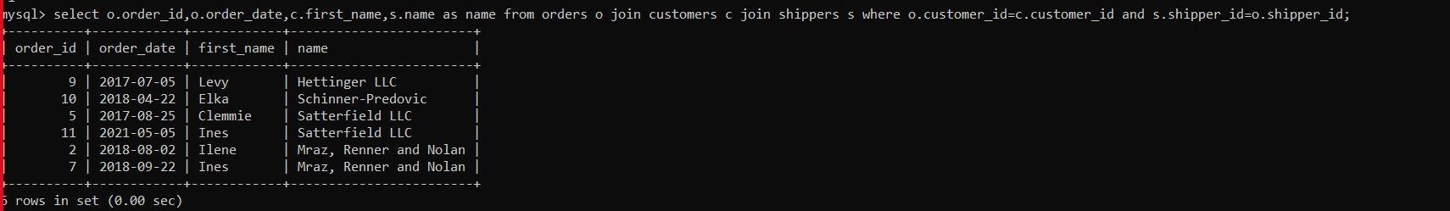

37. Get the output like below table by using JOIN from sql invoicing Data base.

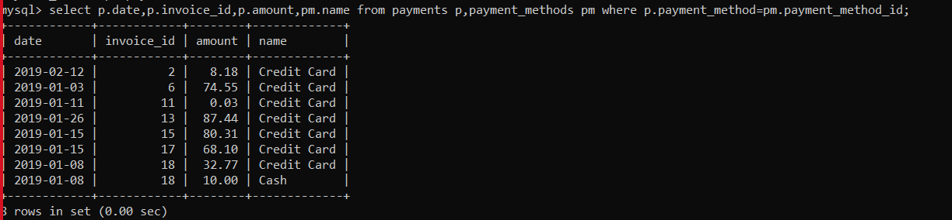

38. Do a cross join between shippers and products, Using explicit syntax and implicit syntax

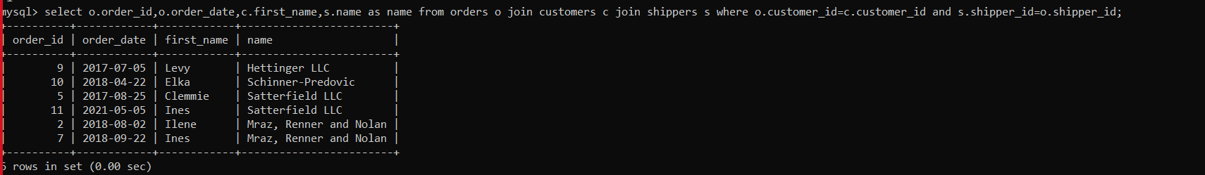

39. Get the output like bellow table.

Ans:

